WWW.VUTUBE.EDU.PK
FINALTERM EXAMINATION
Fall 2009
ECO401- Economics (Session - 3)
Ref No: 1148947
Time: 120 min
Marks: 87

Question No: 1 ( Marks: 1 ) - Please choose one
If the quantity supplied of oranges exceeds the quantity demanded then:

► There is a shortage of oranges.
► Market forces will cause the price to fall.
► Market forces will cause the price to rise.
► The market is in equilibrium.

Question No: 2 ( Marks: 1 ) - Please choose one
Indifference curves that are convex to the origin reflect:

► An increasing marginal rate of substitution.
► A decreasing marginal rate of substitution.
► A constant marginal rate of substitution.
► A marginal rate of substitution that first decreases, then increases.

Question No: 3 ( Marks: 1 ) - Please choose one
Suppose that the price of a pizza is $10 and price of a jeans is $30. If ratio of marginal utility of pizza to marginal utility of jeans is 1/4 then to maximize total utility, a consumer should:

► Buy more pizzas and fewer jeans.
► Buy fewer pizzas and more jeans.
► Continue to buy the same quantities of pizza and jeans.
► Spend more time consuming pizza.

Question No: 4 ( Marks: 1 ) - Please choose one
As long as all prices remain constant, an increase in money income results in:

► An increase in the slope of the budget line.
► A decrease in the slope of the budget line.
► An increase in the intercept of the budget line.
► A decrease in the intercept of the budget line.

Question No: 5 ( Marks: 1 ) - Please choose one
Ali initially leased one-room space and started a small day care centre with only 4 children and one staff member. But he found that the cost per child is very high. He wants to expand the centre. Which of the following will happen when Ali expand the centre?

► Economies of scale.
► Diseconomies of scale.
► Decreasing returns to the labor inputs.
► Increasing returns to the labor inputs.

Question No: 6 ( Marks: 1 ) - Please choose one
Total costs are the sum of:
► Marginal costs and variable costs.
► Fixed costs and variable costs.
► Fixed costs and marginal costs.
► Average variable costs and marginal costs.

Question No: 7 ( Marks: 1 ) - Please choose one
The supply curve for a competitive firm is:
► Its entire marginal cost curve.
► The upward-sloping portion of its marginal cost curve.
► Its marginal cost curve above the minimum point of the average variable cost curve.
► Its marginal cost curve above the minimum point of the average total cost curve.

Question No: 8 ( Marks: 1 ) - Please choose one
A monopolistically competitive firm in short run equilibrium:

► Will make negative profit (lose money).
► Will make zero profit (break-even).
► Will make positive profit.
► Any of the given are possible.

Question No: 9 ( Marks: 1 ) - Please choose one
The marginal revenue product is:

► Upward sloping due to the law of demand.
► Upward sloping due to the law of marginal utility.
► Downward sloping due to the law of diminishing returns.
► Downward sloping due to the law of supply.

Question No: 10 ( Marks: 1 ) - Please choose one
The long run aggregate supply curve will shift to the right if:

► The price level increases.
► Factors of production (such as labor and capital) increase.
► Expenditures (such as consumption and net exports) increase.
► The prices of inputs used to produce goods and services (such as wages and the price of oil) decrease.

Question No: 11 ( Marks: 1 ) - Please choose one
Keynesian economics rejected the classical assumption that:

► Supply creates its own demand.
► Prices and wages are inflexible.
► Self-correction takes a long time.
► Consumption expenditures depend on disposable income.

Question No: 12 ( Marks: 1 ) - Please choose one
Final goods are meant for:

► Direct use by the consumers.
► Further processing.
► The term do not exist.
► None of the given options.

Question No: 13 ( Marks: 1 ) - Please choose one
The slope of the saving function (or line) is the:

► Average propensity to save.
► Average propensity to consume.
► Marginal propensity to save.
► Marginal propensity to consume.

Question No: 14 ( Marks: 1 ) - Please choose one
The investment demand curve shows the relationship between the levels of:

► Investment and consumption.
► Consumption and interest rate.
► Investment and interest rate.
► Investment and saving.

Question No: 15 ( Marks: 1 ) - Please choose one
The circular flow principle guarantees that in equilibrium:

► The level of investment spending will be equal to the level of private savings.
► The level of exports will be equal to the level of imports.
► The level of aggregate demand will be equal to real Gross Domestic Product.
► The level of government spending will be equal to tax revenue.

Question No: 16 ( Marks: 1 ) - Please choose one
The real interest rate will increase:

► If there is an excess supply of loanable funds in the financial markets.
► If there is an excess demand for loanable funds in the financial markets.
► If there is an excess supply of loanable funds in the foreign exchange markets.
► If there is an excess demand for loanable funds in the foreign exchange markets.

Question No: 17 ( Marks: 1 ) - Please choose one
The trend of unemployment over the last forty years is:

► A decrease in unemployment.
► It has remained largely unchanged.
► An increase in unemployment.
► It is too difficult to tell so don't bother.

Question No: 18 ( Marks: 1 ) - Please choose one
The Phillips curve will shift to the right:

► If there is a decrease in the expected inflation rate.
► If there is an increase in the expected inflation rate.
► If there is a decrease in the natural rate of unemployment.
► If there is a favorable supply shock.

Question No: 19 ( Marks: 1 ) - Please choose one
Current account deficit is equal to:

► Private sector resource deficit.
► Government budget deficit.
► Private sector resource deficit + Government budget deficit.
► None of the given options.

Question No: 20 ( Marks: 1 ) - Please choose one
Fiscal policy is the government program with respect to its:

► Steel Mill Privatization.
► Unemployment reduction.
► Expenditure and tax revenue.
► Increase in unemployment.

Question No: 21 ( Marks: 1 ) - Please choose one
In Keynesian economics, an inflationary gap results if:

► Aggregate expenditures are less than aggregate production.
► Aggregate expenditures are greater than aggregate production.
► Aggregate expenditures are equal to aggregate production.
► There are no changes in inventories.

Question No: 22 ( Marks: 1 ) - Please choose one
The accelerator is a related concept which formalizes the investment response to:

► Consumption.
► Interest rate.
► Output.
► None of the given options.

Question No: 23 ( Marks: 1 ) - Please choose one
The principle economic difference between a competitive and a non-competitive market is:

► The number of firms in the market.
► The extent to which any firm can influence the price of the product.
► The size of the firms in the market.
► The annual sales made by the largest firms in the market.

Question No: 24 ( Marks: 1 ) - Please choose one
The amount of output that a firm decides to sell has no effect on the market price in a competitive industry because:
► The market price is determined (through regulation) by the government.
► The firm supplies a different good than its rivals.
► The firm's output is a small fraction of the entire industry's output.
► The short run market price is determined solely by the firm's technology.

Question No: 25 ( Marks: 1 ) - Please choose one
The concept of a risk premium applies to a person that is:

► Risk loving.
► Risk averse.
► Risk neutral.
► Rational.

Question No: 26 ( Marks: 1 ) - Please choose one
Keeping in view the model of aggregate supply and aggregate demand, in the long run, an increase in the money supply should cause:
► Both prices and output to rise.
► Prices to fall and output to remain unchanged.
► Both prices and output to fall.
► Prices to rise and output to remain unchanged.

Question No: 27 ( Marks: 1 ) - Please choose one
Suppose a country has flexible exchange rate and has more rapid inflation rate than other countries. What will happen to its currency in this situation?
► Its currency will appreciate.
► Its currency will depreciate.
► There will be no effect on its currency.
► All of the given options can be possible.

Question No: 28 ( Marks: 1 ) - Please choose one
Which of the following statements best reflects the implication of law of comparative advantage?
► Trade between two countries is always to the advantage of both.
► Trade between two countries can be to the advantage of both even though one may be more productively efficient at producing everything.
► Trade between two countries is to the advantage of both if countries import only those goods that they are incapable of producing themselves.
► Trade between two countries is beneficial to both if the exporter uses less resource than the importer would use to produce the same quantity of goods.

Question No: 29 ( Marks: 1 ) - Please choose one
Firm A produces and sells cotton to firm B for Rs. 500. Firm B makes yarn out of it and sells to firm C for Rs. 700. Firm C makes cloth and sell to consumers for Rs. 1200. Which figure has to be used for finding the economy’s product?
► Rs. 500 of firm A.
► Rs. 700 of firm B.
► Rs. 1200 of firm C.
► Total of all three Rs. 2400.

Question No: 30 ( Marks: 1 ) - Please choose one
The largest contribution in value terms to Pakistan GNP is made by:
► Construction sector.
► Organized industries.
► Unorganized industries.
► Agriculture sector.

Question No: 31 ( Marks: 1 ) - Please choose one
National income figures are:
► Very exact.
► Practically exact.
► Only estimates.
► Wrong.

Question No: 32 ( Marks: 1 ) - Please choose one
A marginal propensity to consume (MPC) of 0.95 indicates that:
► ∆C to ∆Y_{d} is 0.95.
► C / Y_{d} is 0.95.
► ∆Y_{d} to ∆C is 0.95.
► Y_{d} / C is 0.95.

Question No: 33 ( Marks: 1 ) - Please choose one
Which of the following describes the four sources of aggregate demand?
► Consumption, private investment, taxes, and expenditures.
► Consumption, private investment, wage increases, and government expenditures.
► Consumption, private investment, expenditures, and net exports.
► Consumption, private investment, government purchases, and net exports.

Question No: 34 ( Marks: 1 ) - Please choose one
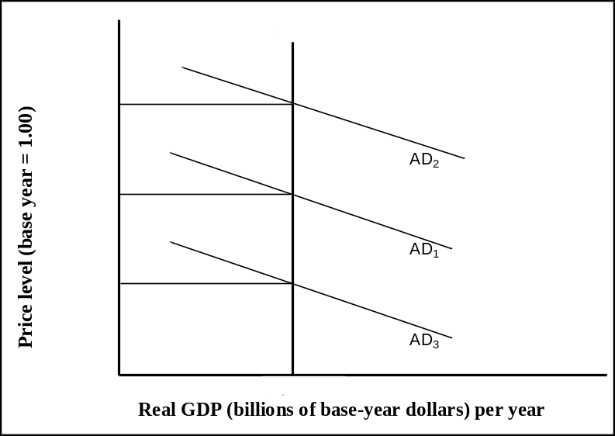
Refer to the above figure, the potential output in this economy is:
► $7,000 billion at a price level of 1.16.
► $7,000 billion at a price level of 1.12.
► $7,000 billion at a price level of 1.08.
► All of the given options.

Question No: 35 ( Marks: 1 ) - Please choose one
Changes in aggregate demand can be caused by changes in:
- Wages.
- Raw materials costs.
- Government spending.
- Government regulations that increase the cost of doing business.
► I, II, III, and IV.
► I and III only.
► I, III, and IV.
► III only.

Question No: 36 ( Marks: 1 ) - Please choose one
The short run in macroeconomic analysis is a period:
► In which wages and some other prices do not respond to changes in economic conditions.
► In which full wage and price flexibility and market adjustment have been achieved.
► Of less than 12 months.
► In which all macroeconomic variables are fixed.

Question No: 37 ( Marks: 1 ) - Please choose one
Which of the following is TRUE?
► 1 − MPS = MPC
► 1 + MPS = MPC
► 1 / MPS = MPC
► 1 × MPS = MPC

Question No: 38 ( Marks: 1 ) - Please choose one
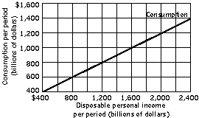
Refer to the above figure, when disposable personal income is $1,200 billion, consumption is:
► $600 billion.
► $800 billion.
► $1,200 billion.
► $2,000 billion.

Question No: 39 ( Marks: 1 ) - Please choose one
Unemployment generally ---------------- when the "real" GDP grows rapidly.
► Remains the same.
► Decreases.
► Increases.
► All of the above are possible.

Question No: 40 ( Marks: 1 ) - Please choose one
Which of the following will influence a country's exports?
► Consumer tastes for domestic and foreign goods.
► Prices of goods at home and abroad.
► Costs of transporting goods from country to country.
► All of the given options.

Question No: 41 ( Marks: 1 ) - Please choose one
Free trade is favoured because:
► Countries have less work to do.
► It leads to greater world efficiency i.e. resources are better utilized.
► Wealthier countries gain an advantage over underdeveloped countries.
► All countries gain from tariff imposition.

Question No: 42 ( Marks: 1 ) - Please choose one
Devaluation is done to:
► Encourage exports.
► Discourage exports.
► Encourage imports.
► Encourage inflation.

Question No: 43 ( Marks: 1 ) - Please choose one
Which of the following will happen by a reduction in net exports all other things being equal?
► It will result in a movement up along the aggregate demand curve.
► It will reduce aggregate supply.
► It will reduce aggregate demand.
► It will not change aggregate demand or aggregate supply in the domestic economy.

Question No: 44 ( Marks: 1 ) - Please choose one
Which of the following is part of M1?
- Savings deposits.
- Cash in your hand.
- Checking deposits.
► I and III.
► II and III.
► I only.
► II only.

Question No: 45 ( Marks: 1 ) - Please choose one
Which of the following is (are) primary function (s) of a central bank?
- Act as a regulator of banks.
- Issue government bonds.
- Set monetary policy.
► I only.
► I and III.
► I and II.
► I, II and III.

Question No: 46 ( Marks: 1 ) - Please choose one
What will be the impact of an increase of $1 in government purchases?
► It will shift the expenditure line upward by $1.
► It will shift the IS curve to the right by $1/ (1 - MPC).
► It will not shift the LM curve.
► All of the given options.

Question No: 47 ( Marks: 1 ) - Please choose one
Countries that are not among the high income nations of the world are categorized as:
► Developed countries.
► Progressed countries.
► Developing countries.
► High income countries.

Question No: 48 ( Marks: 1 ) - Please choose one
Which of the following is a characteristic of low income countries?
► Higher rates of population growth.
► Greater government control.
► A larger share of income used for investment.
► A smaller proportion of the labor force in agriculture.

Question No: 49 ( Marks: 1 ) - Please choose one
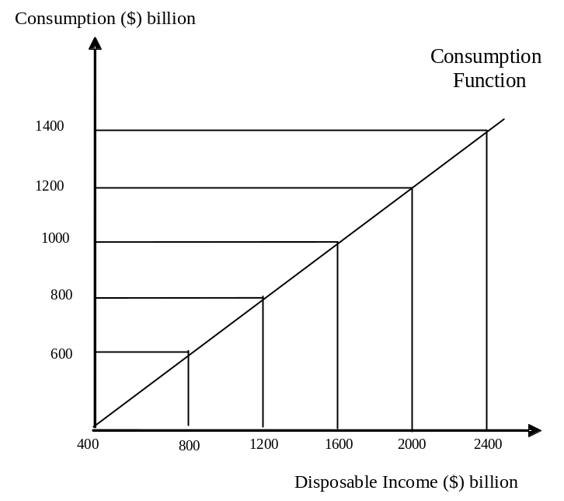
Refer to the above figure, when disposable personal income is $2,000 billion:
► Personal saving is $1,200 billion.
► Consumption is $1,600 billion.
► Saving is $800 billion.
► Consumption is $800 billion.

Question No: 50 ( Marks: 1 ) - Please choose one
How many points you need to know to calculate the price elasticity of demand on the same demand curve?
► One.
► Two.
► Three.
► Four.

Question No: 51 ( Marks: 1 ) - Please choose one
What is meant by the negative slope of a production possibilities curve?
► It means that some resources are always unemployed.
► It means that an economy can produce more of one thing only by producing less of something else.
► It means that opportunity costs are constant.
► It means that business can sell more when prices are low.

Question No: 52 ( Marks: 1 ) - Please choose one
Which of the following will happen if the current market price is set below the market clearing level?
► There will be a surplus to accumulate.
► There will be downward pressure on the current market price.
► There will be upward pressure on the current market price.
► There will be lower production during the next time period.

Question No: 53 ( Marks: 1 ) - Please choose one
For which of the following good, the substitution effect of a lowered price is counteracting by the income effect?
► For an inferior good.
► A substitute good.
► For an independent good.
► For a normal good.

Question No: 54 ( Marks: 1 ) - Please choose one
Which of the following is TRUE about the marginal product of labour in any production process?
► It is total output divided by total labour inputs.
► It is total output minus the total capital stock.
► It is the change in total output resulting from a 'small' change on the labour input.
► It is total output produced by labour inputs.

Question No: 55 ( Marks: 3 )
What are the different components of aggregate demand? Discuss briefly.

Aggregate demand is the total demand for final goods and services in the economy at a given time and price level. It is the amount of goods and services in the economy that will be purchased at all possible price levels. There are four components of aggregate demand which are most important:
- Consumption: Consumption (C) is the amount of national income that is spent on goods and services produced by domestic firms in a given period of time.
- Investment: Investment (I) or gross capital formation is any economic activity that forgoes consumption today with an eye to increase output in future.
- Net Exports: It is net demand from rest of world for country’s output.
- Government Spending: These are gross investments and consumption expenditure done by government.

Question No: 56 ( Marks: 5 )
Explain the difference between Gross National Product (GNP) and Net National Product (NNP) with the help of their formulas.

Difference between GNP and NNP:
- GNP is the value, at current market prices, of all final goods and services produced during a year by the factors owned by the citizens of a country.

GNP = GDP + net factor income from abroad

- NNP is same application as NDP (National Domestic Product) which equal to GDP minus depreciation. Here, deprecation is amount which spends on capital goods that measure GNP. In other words, it is the net output of commodities and services flowing during the year from the country’s production system in the hands of ultimate consumers.

Question No: 57 ( Marks: 5 )
Some economists suggest “growth through resource transfer” and “growth through stabilization and reforms” strategies to tackle the problem of poverty of under developed countries. What is the basic theme of both these strategies? Discuss.

Growth trough resource transfer:
The businesses core resources transfer strategies are having close effect on customer satisfaction, production performance, and personnel expertise of the non-financial performance of business performances; but, these strategies show minor influences on the variance breadth of costs, sales performance, and development performance of business performances. For the growth of it, larger effect exists on the transfer of expertise, organizational learning, reputation and innovation of core resources. However, this strategy shows minor effect on the transfer of brand, management skills, interpersonal relationship, and management.

Growth through stabilization and reforms:
A stabilization strategy centers on addressing people’s basic needs and opportunities at the local level by improving their access to basic services, by expanding economic opportunities and by promoting political/civic empowerment. Livelihood, for the purposes of this strategy, is defined as the combination of factors in a community that have a direct impact on the quality of individuals’ lives. Those factors include the elements in a community that affect citizen well-being, prosperity, and future choices, such as income, health, education, security, water, small infrastructure and citizen participation.

Question No: 58 ( Marks: 10 )
(A) Following are the items of balance sheet of bank A
Loans = 80
Deposits = 100
Reserves = 20
Prepare the balance sheet in proper form and find out total assets and total liabilities.
(B) Following are the items of balance sheet of bank A
Loans = 60
Deposits = 110
Reserves = 50
Firm A deposits Rs. 50 in bank A. Prepare the balance sheet in proper form and find out total assets and total liabilities after the deposits of firm A.
(Marks: 5+5)

Question No: 59 ( Marks: 10 )
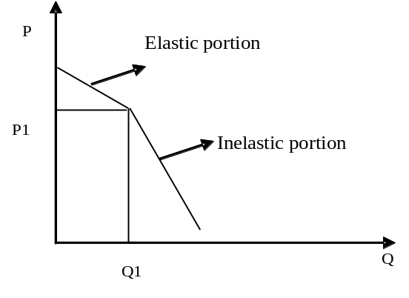
(A) The above demand curve has two distinct segments which have different elasticities that join to form a corner or kink. Why the firms are reluctant to change the price in these two segments?
(B) What are the major advantages that an oligopoly offers for public interests?
(Marks: 5+5)

